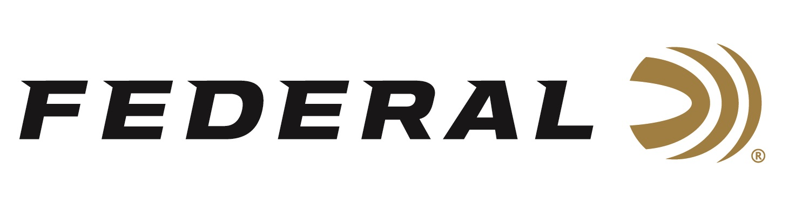

FOR IMMEDIATE RELEASE

Federal Sponsored Shooter Shines at Triple J

ANOKA, Minnesota – March 15, 2023 – Federal Ammunition congratulates sponsored shooter Paul Giambrone for his outstanding performance at the 2023 Triple J Classic held at the National Shooting Complex in San Antonio, TX March 9-12, 2023.

The four-day competition is considered the kick-off event for the National Skeet Shooting Association and draws hundreds of skilled shooters to compete for the first big prize of the season. Giambrone won the Doubles, 20-gauge, and 28-gauge events, finished second in the High Over All and claimed the High All Around title with a combined 498 of 500 targets.

“Paul had a phenomenal weekend,” says Mike Hampton Sr, Team Federal Shooting Manager. “His performance and the Federal ammunition he counts on shows the strength of team Federal. Not often does a competitor start a year by winning multiple events which culminated into the impressive HAA and HOA finishes,” says Hampton.

Giambrone, who came into the competition with limited practice after a family move to Utah said he was inspired by his wife and kids to return to his high competition standards. “Each of them sent me a good luck charm before leaving for Texas,” says Giambrone. “We just got settled into our new home in Utah after living in a camper for nine months and to go to a tournament with focus was extremely helpful having life more simplified,” says the team Federal member.

Giambrone relies on Federal’s Top Gun target loads in 20, 28, and .410 in #9 shot for reliable performance and shot-to-shot consistency.

Federal ammunition can be found at dealers nationwide. For more on Federal ammunition or to shop online, visit www.federalpremium.com.

Press Release Contact: JJ Reich
Senior Manager – Press Relations
E-mail: VistaPressroom@VistaOutdoor.com

About Federal Ammunition
Federal, headquartered in Anoka, MN, is a brand of Vista Outdoor Inc., an outdoor sports and recreation company. From humble beginnings nestled among the lakes and woods of Minnesota, Federal Ammunition has evolved into one of the world's largest producers of sporting ammunition. Beginning in 1922, founding president, Charles L. Horn, paved the way for our success. Today, Federal carries on Horn's vision for quality products and service with the next generation of outdoorsmen and women. We maintain our position as experts in the science of ammunition production. Every day we manufacture products to enhance our customers' shooting experience while partnering with the conservation organizations that protect and support our outdoor heritage. We offer thousands of options in our Federal Premium and Federal® lines-it's what makes us the most complete ammunition company in the business and provides our customers with a choice no matter their pursuit.

